

**Course Title:** Human-Computer Interaction **Course code**: CSE-4451

**Group members: Submitted to:** ● Eashrat Jahan- 011201165 Novia Nourin

● Hasibul Hasan Rupok- 011201002 *Asst. Professor* ● Mahmudul Hasan Bipul- 011201025 *United International university* ● Shah Newaz Aziz - 011201437

1

**Index**

**Section 1: Problem Description.................................................................................................................... 3** 1.1 Problem Statement:..............................................................................................................................3 1.2 User Group:.......................................................................................................................................... 3

**Section 2: Data Collection Process.............................................................................................................. 3** 2.1 Research Methods:.............................................................................................................................. 3 2.2 The process of reaching the target users:............................................................................................ 4 2.3 Participant Demographics:................................................................................................................... 4 2.4 Types of Data Generated from Data Collection Process:....................................................................4 2.5 Data Recording Process:......................................................................................................................5 2.6: Facing and Overcoming the Challenges:............................................................................................ 5

**Section 3: Data Analysis Process.................................................................................................................5** 3.1 Insights from the Affinity Diagram:.......................................................................................................5 3.2 Those we didn’t know:.......................................................................................................................... 6 3.3 Those we confirm that we suspected:.................................................................................................. 6 3.4 Affinity Diagram Link:(Team A)............................................................................................................. 6

**Section 4: User Personas.............................................................................................................................. 7** 4.1 User Persona 1:....................................................................................................................................7 4.2 User Persona 2:....................................................................................................................................8

**Section 5: Scenario And StoryBoard............................................................................................................9** 5.1 Scenario:.............................................................................................................................................. 9 5.2 StoryBoard:...........................................................................................................................................9

2

Section 1: Problem Description

This section contains the problem statement along with the target user group.

1.1 Problem Statement:

School-going children often struggle with keeping up with their homework, understanding difficult subjects, and sticking to a regular study schedule while learning from home. This situation can hinder their educational progress and future opportunities. Our initiative seeks to address these challenges by providing support through a range of features. Our goal is to make learning easier for kids at home, helping them manage assignments better, grasp complex topics, and establish a consistent study routine. Ultimately, we aim to enhance children's learning experiences and set them up for brighter academic prospects.

1.2 User Group:

Our target audience comprises students in grades 4 to 12, ranging in age from 9 to 18 years. Our platform is designed to assist them in enhancing their academic performance by providing support with homework, facilitating comprehension of challenging subjects, and fostering organizational skills for effective home-based studying.

Section 2: Data Collection Process

This section contains the research methodology, participant demographic, generated data, how we record the generated data, and the challenges we face in this process.

2.1 Research Methods:

We talked directly to kids to gather information. We asked them about the problems they have while studying, like which subjects they find tough and how they plan their study time. By understanding their challenges and what kind of help they need from a homework helper, we got the idea to create something that would really assist them. Talking to them helped us figure out what to focus on in our tool.

We chose interviews because talking to the kids helped us understand their thoughts better. By asking questions and listening to their answers, we got detailed insights into their needs and the exact help they wanted from a homework helper. Interviews let us connect with them and learn from their experiences, guiding us to create a helpful tool that truly meets their requirements.

3

2.2 The process of reaching the target users:

We have personally gone to the residences of students across various academic levels. The purpose of these visits was to meet the students in their homes and collect information, indicating a hands-on approach to understanding their situations and needs.

2.3 Participant Demographics:

Here we have discussed the demographics of the participants of our interview. Here we mentioned the name, age, gender, and grade. Here, we've used a made-up name as we assured them that we wouldn't disclose their real identity. Table~1 contains the demographic information of the participants.

| **Name** | **Age** | **Grade** | **Gender** |
| --- | --- | --- | --- |
| Lamanna | 16 | 10 | Female |
| Nazifa | 12 | 6 | Female |
| Siam | 11 | 5 | Male |
| Sami | 17 | 11 | Male |
| Punom | 10 | 4 | Female |
| Taohid | 14 | 8 | Male |

Pranom 10 4 Male Roman 15 10 Male Tamim 16 10 Male Nabila 16 10 Female

Rony 10 4 Male

Ratri 11 5 Female Table 1: Demographic Information of the Participants.

2.4 Types of Data Generated from Data Collection Process:

We carefully collected information by using a detailed questionnaire to ask the participant group about their study habits and challenges. We talked to them, took notes, and made sure to understand their thoughts about homework, difficulties, and any extra feedback they had. The questionnaire helped us to ask questions in an organized way. The notes we took during the interviews are like a treasure of information, giving us a clear picture of each participant's age, how they study, and what makes their learning experience special, etc.

4

The notes obtained from these interviews serve as qualitative data. This qualitative data will help us to gain insights to better assist in solving the users' problems in the next steps.

2.5 Data Recording Process:

Initially, we have recorded the collected data as notes and then we stored the data in a CSV file.

2.6: Facing and Overcoming the Challenges:

This section contains the challenges that we face during the data collection process and how we overcome these challenges.

● Challenge: Kids might find it hard to give detailed answers because they're young. Solution: Used questions and things like pictures to make it easier for them to talk. ● Challenge: People might understand questions differently because they come from different backgrounds.

Solution: Made sure interviewers knew how to ask questions the same way every time. ● Challenge: Make sure the kids feel comfortable and not scared to talk.

Solution: Tried to make the interviews a friendly and welcoming environment.

● Challenge: students were initially reluctant to identify their weaknesses. For instance, they might be facing difficulties in specific subjects but don’t want to share frankly

Solution: We prompted them by mentioning specific subject names, and upon doing so, they agreed that they were facing challenges in those particular subjects.

Section 3: Data Analysis Process

3.1 Insights from the Affinity Diagram:

Here are the final insights from the affinity diagram:

● *Image-Based Study Material*: Most of the students under 13 tend to prefer materials that include images, as they find them helpful for better understanding.

*● Scenario-Based Study Material:* 11 and 12-grade students mainly preferred scenario-based learning. *● Unable to Find Resources:* There are some participants who still don't know how to find a solution from the internet, and some also complain that the solutions are paid.

● *Resource Understanding:* Some participants said that if they find any solution to any mathematical problem, sometimes they can find the solution but there exists no explanation.

● *Study Plan:* There exist both types of students who prefer planned(routine-based) and non-planned study.

● *Difficult Subject:* Most of the participants said they face difficulties in math and physics. ● *Help for Homework:* Most of the participants take help from online for their homework, some prefer tutors, and very few of them take help from their parents.

5

● *Study Type:* According to our participants, 50% preferred group study, and the other 50% preferred solo study

3.2 Those we didn’t know:

This section includes data that was not anticipated or expected to be provided by the users. It implies that the content within this section holds unexpected insights or details that may not have been initially considered during the information-gathering process:

● We did not anticipate that many individuals were still unaware of how to use the internet, which was somewhat unexpected. This aspect of limited internet literacy came as a surprise during our interactions.

● A majority of the students exhibit a weakness in mathematics. This is evident in their struggles to grasp mathematical concepts and solve problems effectively. The prevalence of difficulties in this subject indicates a common challenge among the student population.

3.3 Those we confirm that we suspected:

This section contains information about certain aspects that we had anticipated or considered possible before conducting the interviews. Ultimately, after conducting the interviews, we have confirmed that our initial anticipations were accurate:

● We understood that students may find it easier to gain knowledge from image-based and scenario-based data rather than textual information. We have confirmed this through feedback from participants.

● When it comes to comprehending topics in any subject, a majority of students express a preference for live classes, which aligns with our expectations that we had anticipated before conducting the interview sessions.

3.4 Affinity Diagram Link:(Team A)

Click here to view the affinity diagram.

6

Section 4: User Personas

4.1 User Persona 1:

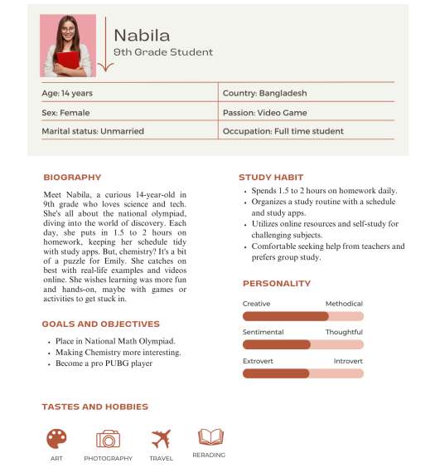7

4.2 User Persona 2:

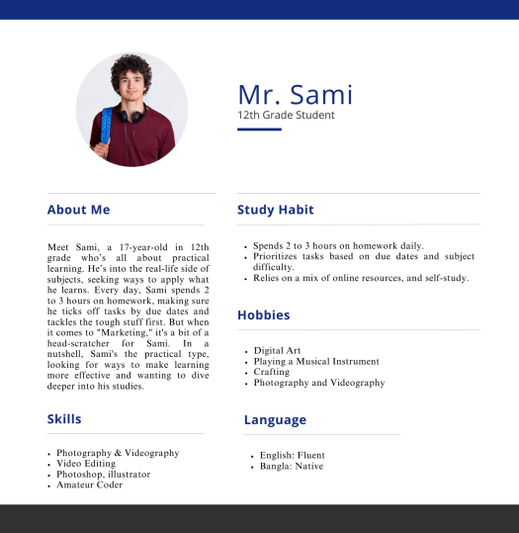8

Section 5: Scenario And StoryBoard

A scenario is a brief overview of events in a situation, offering a guide for decision-making. A storyboard, on the other hand, uses comic-style frames or dialogues to visually outline scenes, acting as a blueprint for visual storytelling like film or animation.

5.1 Scenario:

Nazifa, a diligent 6th-grade student, struggled with math concepts. Online searches for study materials left her overwhelmed and confused. The available text-based resources failed to engage her, making comprehension challenging. Sometimes she along with some of her friends decided to do group study. With shared insights and discussions, Nazifa not only grasped difficult concepts but also discovered a supportive learning community but they are not satisfied with it because always doing group study can't happen. She wants to find a better solution that can be sustainable, and available for 24/7 hours.

5.2 StoryBoard:

In this sub-section, we have presented a comic-style story between two students talking about their sufferings. You will find the story in comic~1 on the next page.

9

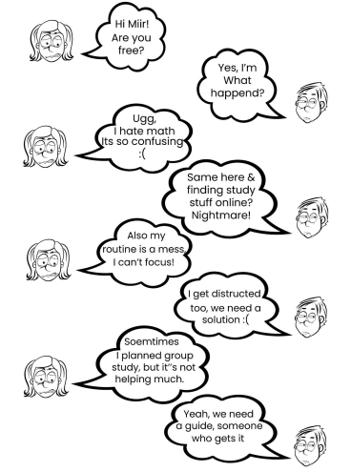Comic 1: A story between 2 friends regarding their sufferings

10